**CONCEPTION PHASE**

The project aims to create a database for renting a place to stay like apartments or bedrooms. This database is the data persistence part of the platform users’ input, which is used for the back-end. The platform aims to contract between host and guest booking; therefore, the database is based on the user role to keep transactions. Some restrictions need to have functioned with the front-end of the platform, for-example host is not paid until twenty-four hours after the guest is satisfied with what is described on a platform and what s/he sees on the facility. In another example of front-end restrictions functionality, the host has to provide at least one picture and phone, but the guest has to provide more information than that to be a verified user. This project will not focus on how to build front-end applications, but on how to make data persistent by using SQL (Structured data Query Language) based database for a platform that is part of the back-end. The problem description for the project can be summarized as, keeping records of the users. The host has the facility, for example, s/he wants to keep records of the facility locations, guest records, and their details such as invoice order. Also, guest can keep their order records. The advantages of this method is to have historical data of the facility’s and historical data of guests’. Disadvantages of this method is that user need to spend some time to enter input and also facility administrator need to spend some time to enter input to the platform as well as this can be employed an extra employee for the facility. After the problem is defined well, there will be ERM (Entity Relationship Model) for the emphasized database. The figure will be placed on the last page of the conception phase. There will be twenty-one entities in the database model, each database has its structured data to increase efficiency so that the use case can be more scalability and can be run faster while querying through SQL. No-SQL based database systems will not be used on this project as SQL based solutions widely used on industry. The list of entities and a short description of tables are shown below:

|  |  |  |
| --- | --- | --- |
| **No** | **Tables** | **Description** |
| **1** | userRole | It defines user role e.g., Guest/Host |
| **2** | userTaxId | User Tax Id for invoices |
| **3** | bank | To keep record of bank accounts |
| **4** | carrier | To keep details of shipment |
| **5** | expectedIncome | Host may want to analyze expected and real income |
| **6** | facilityRate | To keep record of guest rate for the facility |
| **7** | facilityOrder | Facility orders |
| **8** | facilityLocation | Geo-location of facility |
| **9** | facilitySocial | Saves facility social media links |
| **10** | facilityArchitecture | Architectural properties |
| **11** | facilityPrice | Keep records of facility price per day |
| **12** | facilityInvoice | facility invoice belongs to user |
| **13** | facilityAvailability | keep availability dates |
| **14** | facility | place to be stay |
| **15** | facilityReview | Comments of guest to be saved |
| **16** | facilityTaxRate | tax rate for invoice |
| **17** | facilityOverDayStayed | guest can stay more than planned as days |
| **18** | facilityAdvantages | advantages of facility |
| **19** | accountPayable | payments details |
| **20** | accountReceivable | receive details |
| **21** | employee | employee details |

Table 1 List of Entries

These tables are connected so that SQL queries can run via joining tables to each other. Therefore, the conception project is to build the database for CRUD (Create, Read, Update, Delete) operations. However, only Create and Read statements will be used in this project for simplicity and not to complicate the project. After the ERM (Entity Relationship Model) has been built, tables are also identified and designed with their column and data types. All primary keys are unique, not null, and auto increment in each table. Primary keys are mostly used to connect tables so that each row can be identified when SQL queries are running, there will be also foreign keys on the corresponding table while foreign keys are the primary keys of a connected table. MySQL database is used for the database, with MySQL workbench GUI (graphical user interface) for database modeling. The reason of choosing MySQL workbench GUI is to holistically have solution for the project. Int, varchar, timestamp, data types will be used for a variety of input. Relationships are mostly one-to-many but there are also many-to-many relationships that exist. On many-to-many relationships, has an extra table between two tables that will keep records of both primary keys to match records. However, these extra tables from many-to-many relationships are not included in the table list above. As Each table and its columns can be seen below, SQL statements;

|  |  |  |  |  |
| --- | --- | --- | --- | --- |
| **userRole** |  |  | **carrier** |  |
| id_userRole | INT |  | id_carrier | INT |
| userRole | VARCHAR(45) |  | name | VARCHAR(50) |
| name | VARCHAR(45) |  | itemSent | VARCHAR(45) |
| surname | VARCHAR(45) |  | trackingNo | VARCHAR(25) |
| email | VARCHAR(45) |  | create_time | TIMESTAMP |
| telephone | VARCHAR(45) |  | update_time | TIMESTAMP |
| create_time | TIMESTAMP |  |  |  |
| update_time | TIMESTAMP |  | **bank** |  |
|  |  |  | id_bank | INT |
| **userTaxId** |  |  | bankName | VARCHAR(250) |
| id_userTaxId | INT |  | iban | VARCHAR(50) |
| userTaxNo | VARCHAR(25) |  | accountHolderNameSurname | VARCHAR(50) |
| create_time | TIMESTAMP |  | create_time | TIMESTAMP |
| update_time | TIMESTAMP |  | update_time | TIMESTAMP |
|  |  |  |  |  |
| **facilityRate** |  |  | **expectedIncome** |  |
| id_facilityRate | INT |  | id_expectedIncome | INT |
| rate | INT |  | expectedIncome | INT |
| create_time | TIMESTAMP |  | create_time | TIMESTAMP |
| update_time | TIMESTAMP |  | update_time | TIMESTAMP |
|  |  |  |  |  |
| **facilityOrder** |  |  | **facilityLocation** |  |
| id_facilityOrder | INT |  | id_facilityLocation | INT |
| dayOrder | INT |  | latitude | VARCHAR(45) |
| id_userRole | INT |  | longitude | VARCHAR(45) |
| create_time | TIMESTAMP |  | cityName | VARCHAR(45) |
| update_time | TIMESTAMP |  | countryName | VARCHAR(45) |
|  |  |  | create_time | TIMESTAMP |
|  |  |  | update_time | TIMESTAMP |
|  |  |  |  |  |
| **facilitySocial** |  |  | **facilityArchitecture** |  |
| id_facilitySocial | INT |  | id_facilityArchitecture | INT |
| facebookLink | VARCHAR(150) |  | hasRoom | INT |
| instagramLink | VARCHAR(150) |  | totalSq | INT |
| create_time | TIMESTAMP |  | hasBalcoon | TINYINT |
| update_time | TIMESTAMP |  | create_time | TIMESTAMP |
|  |  |  | update_time | TIMESTAMP |
|  |  |  |  |  |
| **facilityPrice** |  |  | **facilityReview** |  |
| id_facilityPrice | INT |  | id_facilityReview | INT |
| pricePerDay | INT |  | guestComment | VARCHAR(150) |
| create_time | TIMESTAMP |  | create_time | TIMESTAMP |
| update_time | TIMESTAMP |  | update_time | TIMESTAMP |
|  |  |  |  |  |
| **facilityInvoice** |  |  | **accountReceivable** |  |
| id_facilityInvoice | INT |  | id_acctReceivable | INT |
| stayedDay | INT |  | amount | INT |
| dailyPrice | INT |  | orgName | VARCHAR(50) |
| create_time | TIMESTAMP |  | address | VARCHAR(50) |
| update_time | TIMESTAMP |  | create_time | TIMESTAMP |
|  |  |  | update_time | TIMESTAMP |
| **facility** |  |  |  |  |
| id_facility | INT |  | **facilityTaxRate** |  |
| type | VARCHAR(45) |  | id_facilityTaxRate | INT |
| name | VARCHAR(45) |  | taxRate | INT |
| adress | VARCHAR(45) |  | create_time | TIMESTAMP |
| email | VARCHAR(45) |  | update_time | TIMESTAMP |
| telephone | VARCHAR(45) |  |  |  |
| create_time | TIMESTAMP |  | **facilityOverDayStayed** |  |
| update_time | TIMESTAMP |  | id_facilityOverDayStayed | INT |
|  |  |  | overDays | INT |
| **employee** |  |  | create_time | TIMESTAMP |
| id_employee | INT |  | update_time | TIMESTAMP |
| name | VARCHAR(50) |  |  |  |
| surname | VARCHAR(50) |  | **facilityAdvantages** |  |
| telephone | VARCHAR(50) |  | id_facilityAdvantage | INT |
| create_time | TIMESTAMP |  | advantage | VARCHAR(45) |
| update_time | TIMESTAMP |  | create_time | TIMESTAMP |
|  |  |  | update_time | TIMESTAMP |
| **accountPayable** |  |  |  |  |
| id_acctPayable | INT |  | **facilityAvailability** |  |
| amount | INT |  | id_facilityAvailability | INT |
| orgName | VARCHAR(50) |  | availableStartDate | TIMESTAMP |
| address | VARCHAR(50) |  | availableEndDate | TIMESTAMP |
| create_time | TIMESTAMP |  | create_time | TIMESTAMP |
| update_time | TIMESTAMP |  | update_time | TIMESTAMP |

Table 2 list of attributes

At the below page it may be seen the Entity Relation Model.

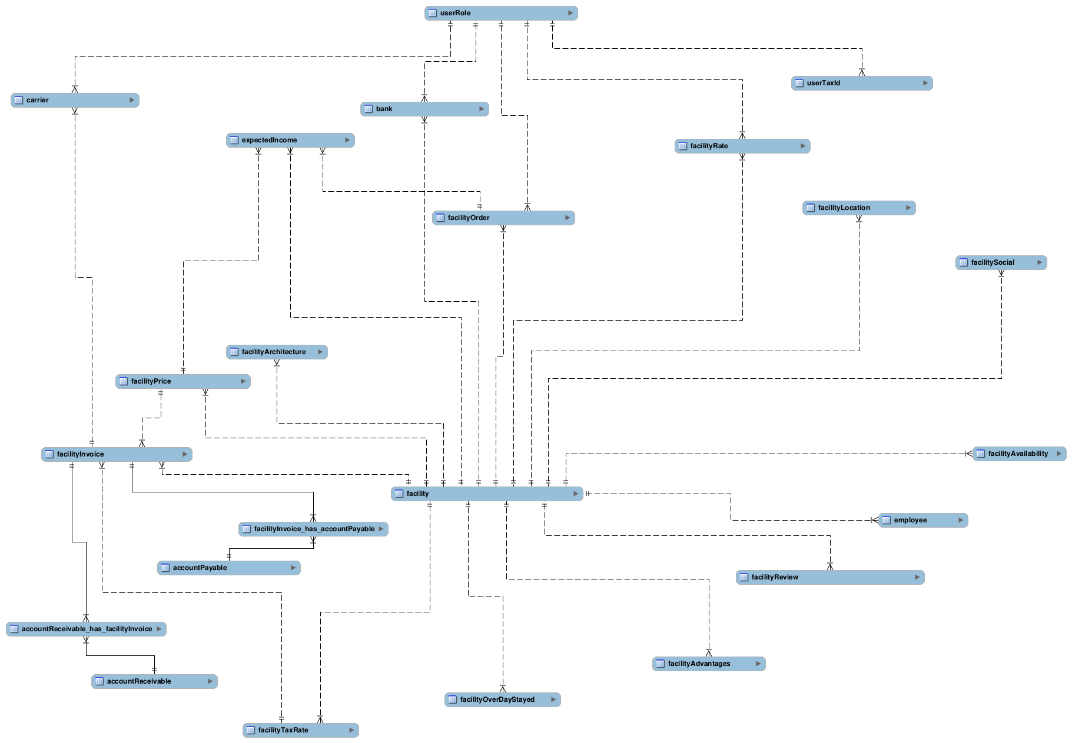

Figure 1 ERM of database